CHC32015M Certificate III in Community Services
Release 3

CHC32015M Certificate III in Community Services

Modification History
Release | Comments
Release 1 | This version released with CHC Community Services Training Package Version 11.  CHC32015M Certificate III in Community Services supersedes and is not equivalent to CHC32015 Certificate III in Community Services.  Major changes to core and elective units of competency.

Qualification code  DRAFT  Mandatory field | CHC32015M
Qualification title  Mandatory field | Certificate III in Community Services
Qualification description  Mandatory field | This qualification prepares individuals for entry-level community services roles, enabling them to provide person-centred support to individuals and/or groups. Work is performed under direct or indirect supervision, with individuals taking some responsibility for their own outputs.  The skills in this qualification must be applied in accordance with Commonwealth and State or Territory legislation, Australian standards and industry codes of practice.
Foundation skills outcomes  Mandatory field | The foundation skills outcomes implicit in this qualification are outlined in the below bar chart.  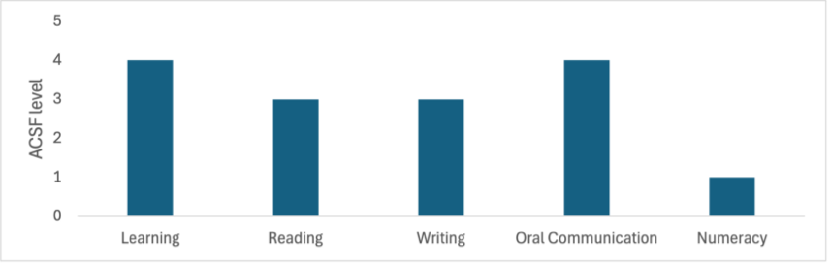  Note: Some elective units require higher foundation skills levels. Please refer to the Companion Volume Implementation Guide for more information.
Entry requirements  Optional field | N/A
Qualification mapping information  Mandatory field | CHC32015M Certificate III in Community Services supersedes and is not equivalent to CHC32015 Certificate III in Community Services
Packaging Rules  DRAFT | Total number of units = 12  - 8 core units  - 4 elective units, consisting of:  - at least 2 units from the electives listed below  - up to 2 units from the electives listed below, any endorsed Training Packages or accredited courses – these units must be relevant to the work outcome  All electives chosen must contribute to a valid, industry-supported vocational outcome.  * Indicates proposed draft title – subject to further consultation  M indicates proposed major changes  X indicates cross sector
  Core Units
  CHCCCS016M | Respond to client needs
  CHCCOM005M | Communicate and work in health or community services
  CHCDIV001M | Work with diverse people
  CHCDIV002M | *Support culturally responsive practices with Aboriginal and/or Torres Strait Islander peoples
  CHCLEG001 | Work legally and ethically
  CHCMHS007 | Work effectively in trauma-informed care
  HLTWHS002 | Follow safe work practices for direct client care
  HLTWHS006 | Manage personal stressors in the work environment
  Elective units
  BSBINS302 | Organise workplace information
  BSBLDR301 | Support effective workplace relationships
  BSBOPS101 | Use business resources
  BSBPEF301 | Organise personal work priorities
  BSBSTR301 | Contribute to continuous improvement
  BSBTEC201 | Use business software applications
  BSBTEC203  DRAFT | Research using the internet
  BSBWRT311 | Write simple documents
  CHCADV001 | Facilitate the interests and rights of clients
  CHCAOD001 | Work in an alcohol and drugs context
  CHCAOD002M | *Work with people who are intoxicated
  CHCAOD003 | Provide needle and syringe services
  CHCCCS003M | *Increase the safety of people at risk of suicide
  CHCCCS005M | Conduct individual assessments
  CHCCCS009M | Facilitate responsible behaviour
  CHCCCS017 | Provide loss and grief support
  CHCCCS019 | Recognise and respond to crisis situations
  CHCCCS026 | Transport individuals
  CHCCCS028M | *Provide person-centred support to people in crisis
  CHCCCS031 | Provide individualised support
  CHCCCS033 | Identify and report abuse
  CHCCCS038 | Facilitate the empowerment of people receiving support
  CHCCCS040 | Support independence and wellbeing
  CHCCDE017 | Support collaborative planning processes
  CHCCDE019 | Work within a community development framework
  CHCCDE020 | Implement participation and engagement strategies
  CHCCOM001M | Provide first point of contact
  CHCDEV004M | Confirm developmental status
  CHCDFV001M | *Identify and respond to family, domestic and/or sexual violence
  CHCDIS011 | Contribute to ongoing skills development using a strengths-based approach
  CHCDIS012 | Support community participation and social inclusion
  CHCDIS020 | Work effectively in disability support
  CHCDIV002M | *Support culturally responsive practices with Aboriginal and/or Torres Strait Islander peoples
  CHCEDU003 | Provide sexual and reproductive health information to clients
  CHCEDU005 | Work with clients to identify financial literacy education needs
  CHCEDU009  DRAFT | Provide parenting, health and well-being education
  CHCGMB001 | Assess the needs of clients with problem gambling issues
  CHCGRP001 | Support group activities
  CHCGRP003 | Plan, facilitate and review psycho-educational groups
  CHCMHS001M | *Work with people with mental health challenges
  CHCPRP001 | Develop and maintain networks and collaborative partnerships
  CHCPRT025 | Identify and report children and young people at risk
  CHCSET003 | Work with forced migrants
  CHCSET004 | Undertake bicultural work with forced migrants in Australia
  CHCSOH013 | Work with people experiencing or at risk of homelessness
  CHCVOL001 | Be an effective volunteer
  CHCYTH013 | Engage respectfully with young people
  CHCYTH015 | Support young people to create opportunities in their lives
  FSKDIG003 | Use digital technology for non-routine workplace tasks
  FSKLRG006 | Participate in work placement
  HLTAAP001 | Recognise healthy body systems
  HLTAID011 | Provide first aid
  HLTHPS006 | Assist clients with medication
  PSPLAN003 | Source information on Deaf culture, and communicate according to Deaf protocol
  SITXFSA006 | Participate in safe food handling practices
  TLIC0031 | Apply low risk car driving behaviours

DRAFT

